

**Jig Order Monitoring System**

Work Instruction V2

IT | System Group

**Table of Contents**

|  |  |
| --- | --- |
| 1. System Process Flow | 2 |
| 1. MPPD1 / Request Interface 2. Login 3. Import Multiple Request Data 4. Add Single Item Request Data 5. Request Monitoring 6. Cancellation Request 7. Account Management 8. Logout | 3 |
| 1. AME3 / Purchasing Interface 2. Login 3. Request Data 4. Set RFQ + PO Process 5. Export Request 6. Import Request 7. Cancellation Request 8. Closed Request History 9. Account Management 10. Logout | 8 |
| 1. AME2 / Installation Interface 2. Login 3. Request Without Installation Date 4. Installation Process 5. Request With Installation Date 6. Account Management 7. Logout | 14 |

1. **System Process Flow**

Log in to Jig Order Monitoring System

AME1 import/add multiple/single request data

Notify AME3 for the pending request

Export pending request and import Initial RFQ, RFQ, and PO process

View the closed request data history for

a specific date

AME2 install and generate request based on installation date

AME1 monitor the delayed request data

1. **MPPD1 / Request Interface**
2. **Login**

1.1 Enter Username and Password. *(See Figure 1)*

1.2 Click Sign In Button to access Main Form. *(See Figure 1)*

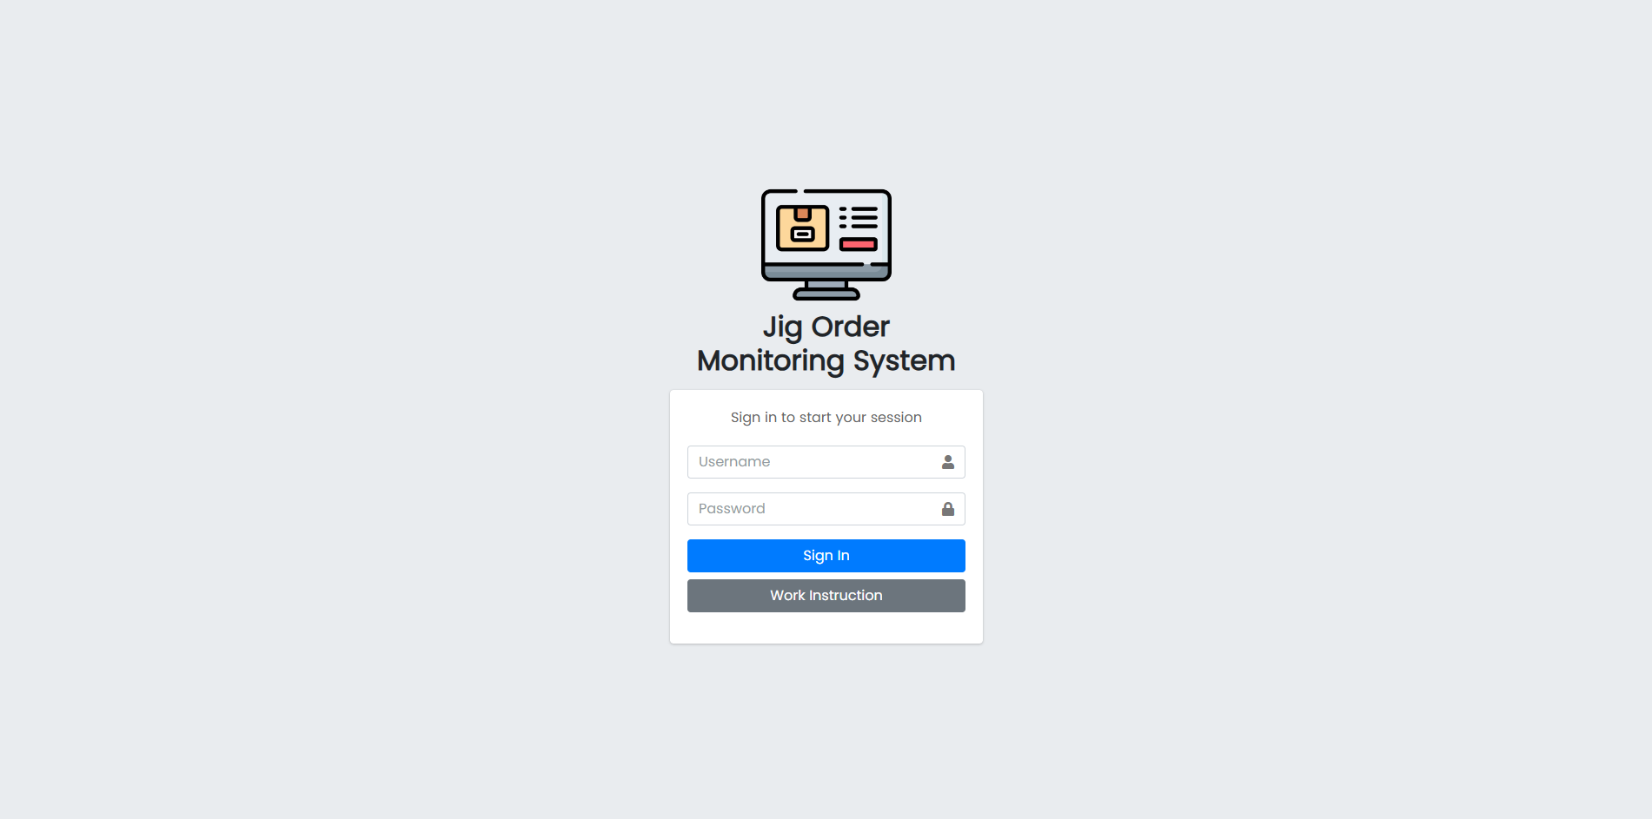

1.1

1.2

*Figure 1. Login Page*

1. **Import Multiple Request Data**

2.1 In the navigation bar, click Import Request Data. *(See Figure 2)*

2.2 The user can download the template by clicking the Proceed button as shown in the figure above *(See Figure 2).*

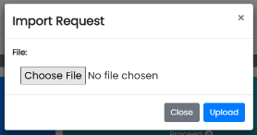 2.2.1 Open template for request.csv and encode the request data then save the file. (See Figure 3)

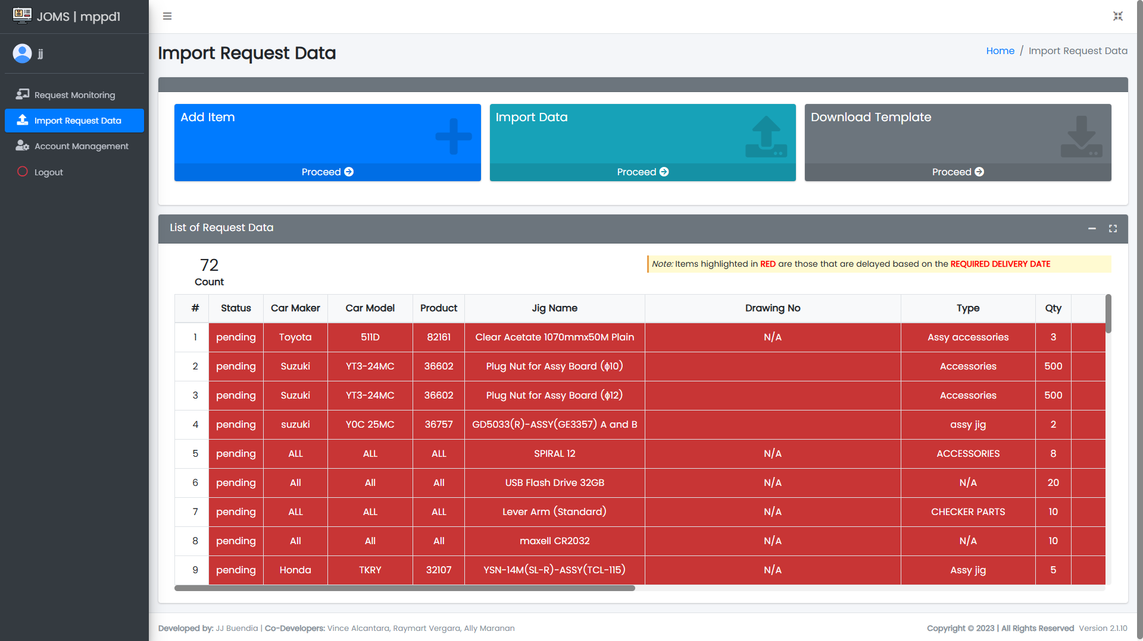

3.1

2.3

2.2

2.1

*Figure 2. MPPD1 Import Request Data Page*

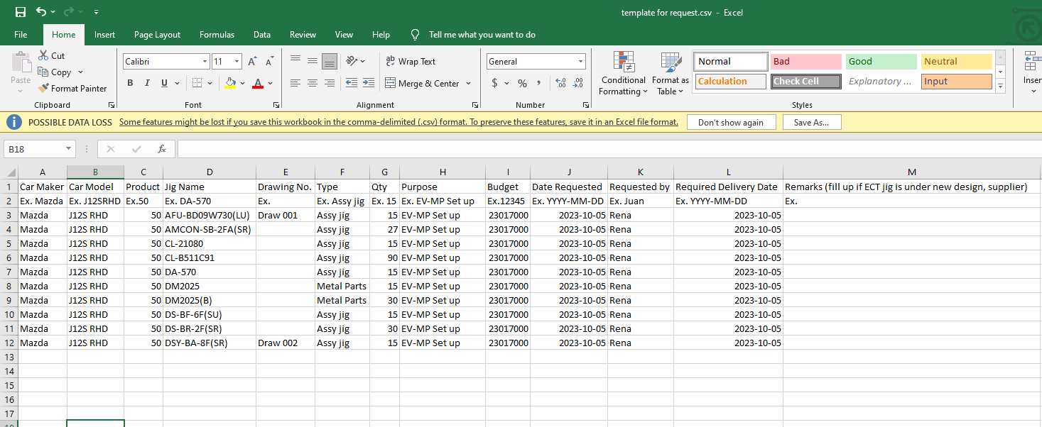

*Figure 3. Sample File*

2.3 Click proceed in Import Data then click on the Choose File button. *(See Figure 2)*

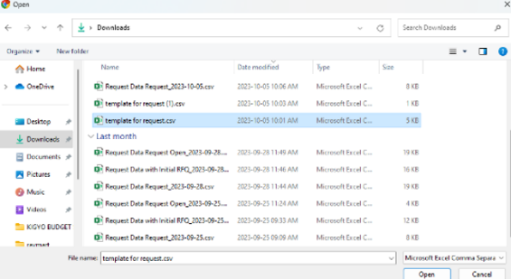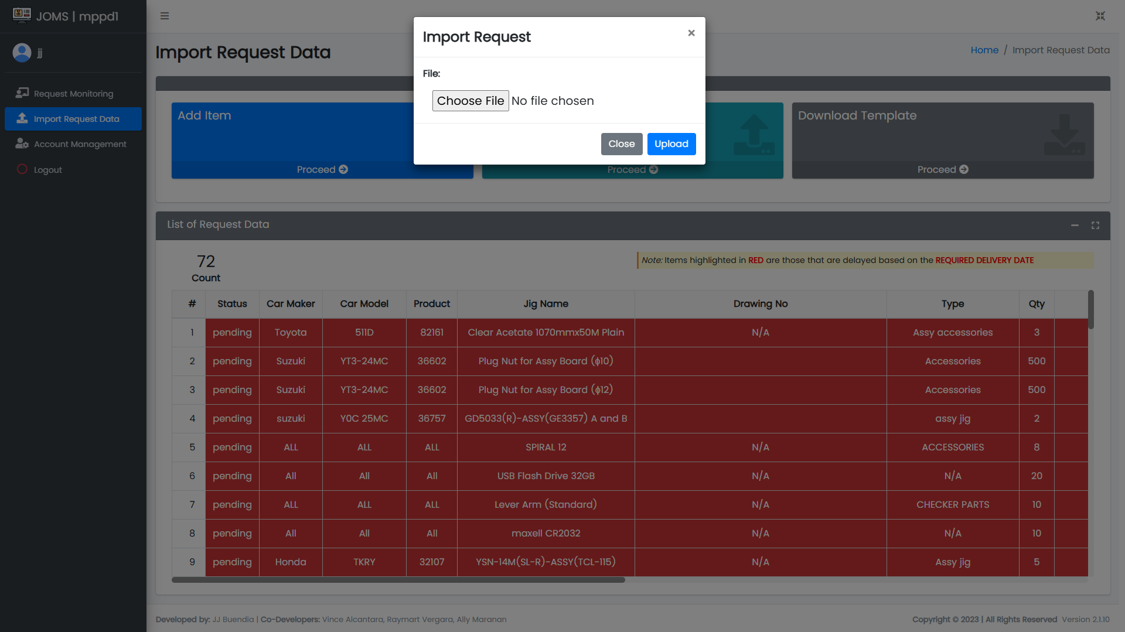

2.4

*Figure 4. Template for Request*

2.4 Import the data using the downloaded template with the encoded request data. Note that incorrect format will result to error. *(See Figure 4)*

1. **Add Single Item Request Data**

3.1 Click on the proceed button of the Add Item. *(See Figure 2)*

3.2 Fill out all the needed details in the form, then click on the Add Item button. *(See Figure 5)*

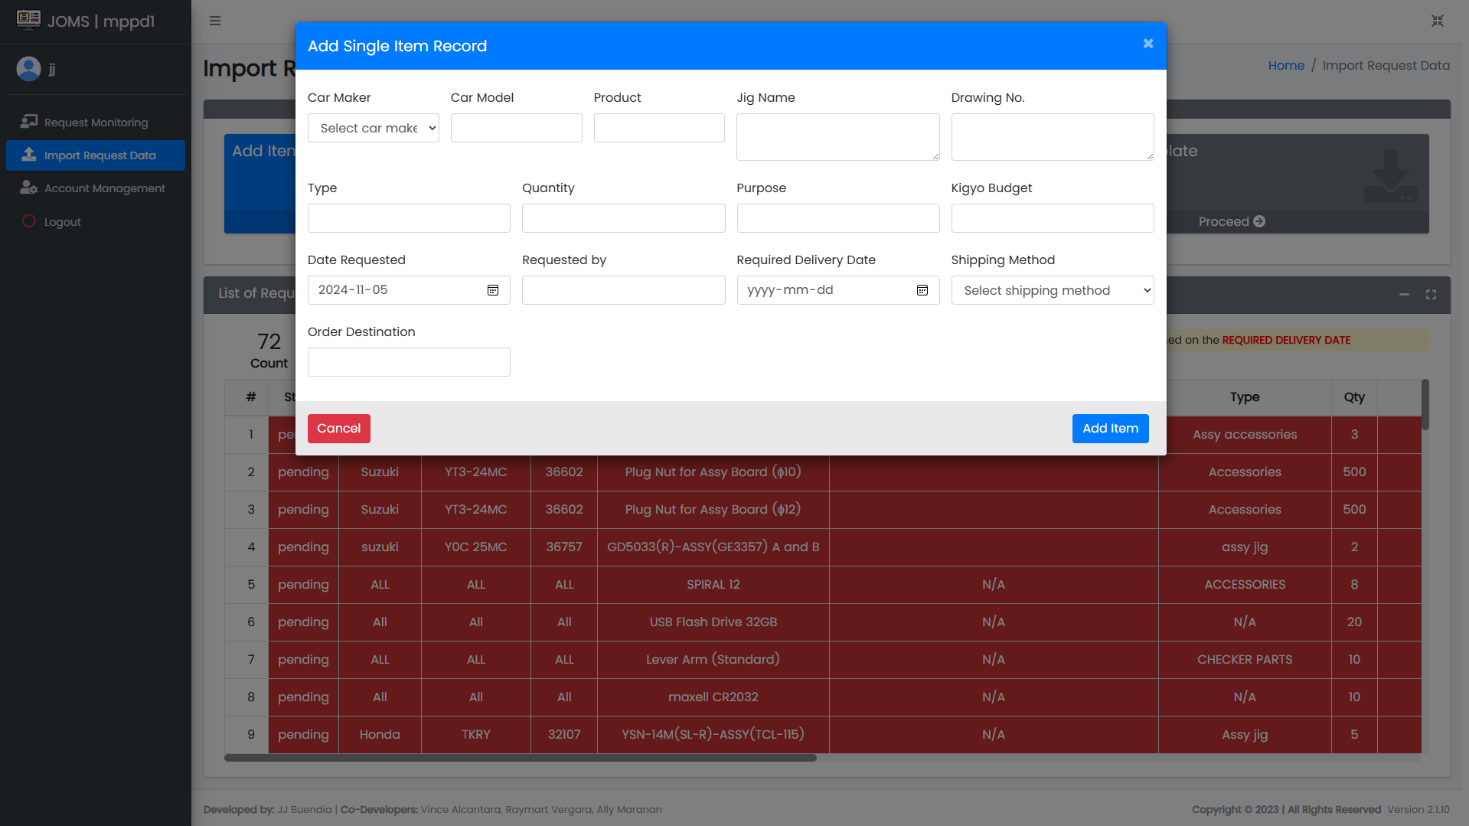

3.2

*Figure 5. Single Item Record Form*

1. **Request Monitoring**

4.1 In the navigation bar, click Request Monitoring. *(See Figure 6)*

4.2 To filter the table; select Section, Status, Date From, and Date To. *(See Figure 6)*

4.3 Shows the total count of data displayed in the table. The rows are highlighted if the Required Delivery Date column is delayed. *(See Figure 6)*

4.4 Click Export Filtered Record button to get data based on filtered search. *(See Figure 6)*

4.5 Click Export All Record button to get all record. *(See Figure 6)*

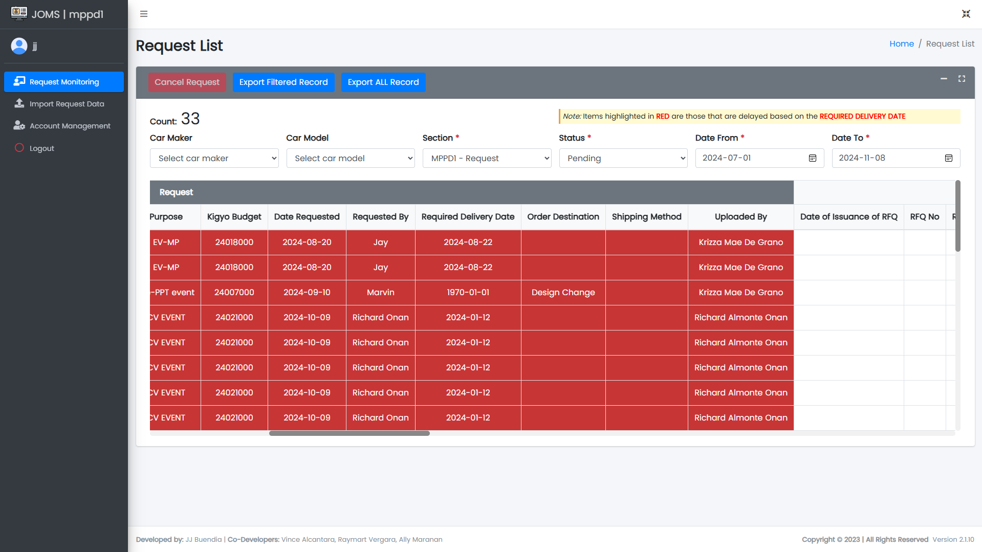

4.3

4.4

4.5

4.1

4.3

4.2

*Figure 6. MPPD1 Request Monitoring Page*

1. **Cancellation Request**

5.1 To cancel, select the checkbox of item that needs to be cancelled. *(See Figure 7)*

5.2 Click the Cancel Request button to show the Cancellation for Selected Request. *(See Figure 7)*

5.3 Provide cancellation reason and cancellation date then, click the Confirm button. *(See Figure 7)*

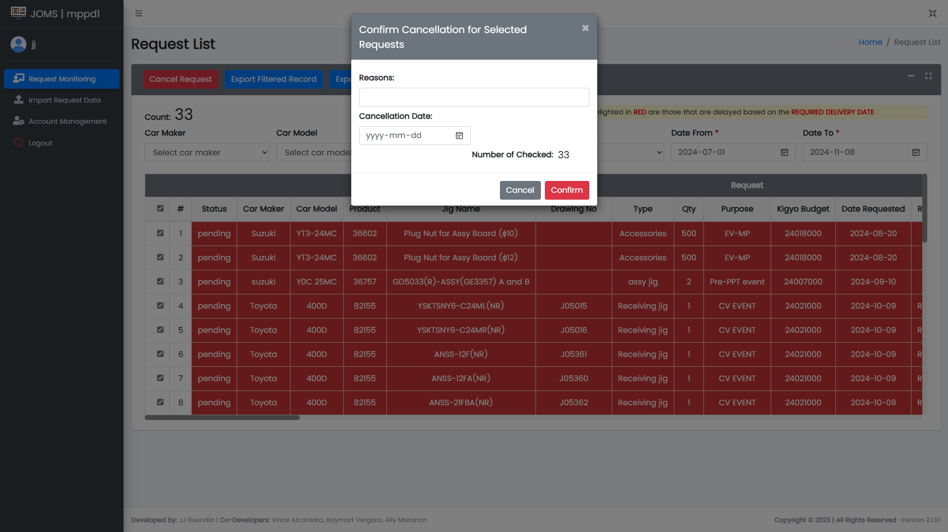

5.2

5.3

5.1

*Figure 7. Cancellation Request*

5.4 Click Section, the Status must be Cancelled, then set the Date From and Date To. *(See Figure 8)*

5.5 Click Cancelled under Status column. *(See Figure 8)*

5.6 View the cancelled data. *(See Figure 8)*

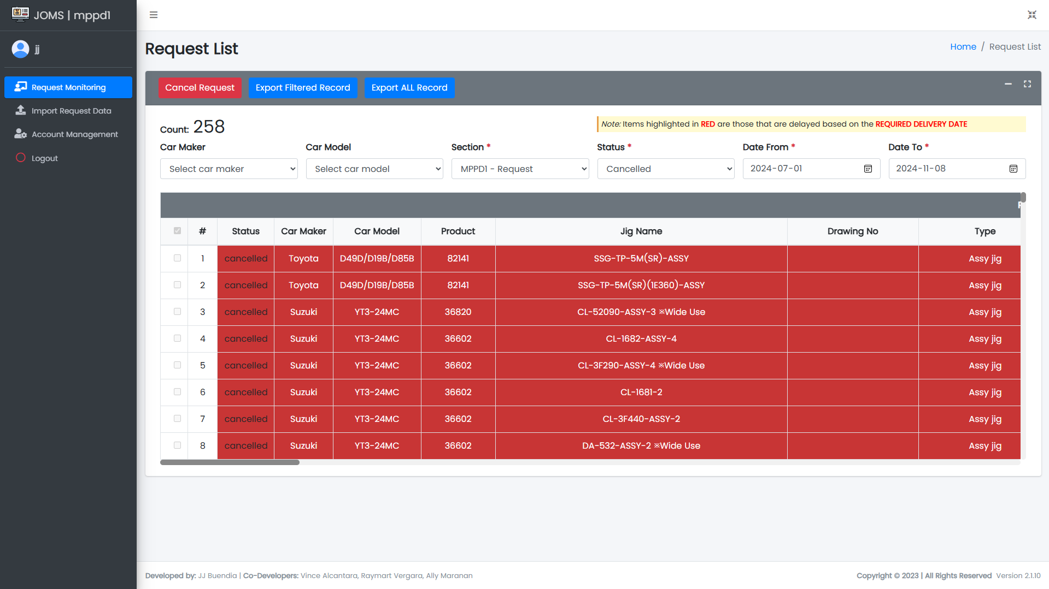

5.6

5.4

5.5

*Figure 8. View Cancelled Data*

1. **Account Management**

6.1 Click the Account Management. *(See Figure 9)*

6.2 Click Add Account to create an account. *(See Figure 9)*

6.3 View table of accounts. To update, click row of data to be updated and same goes when deleting an account. *(See Figure 9)*

6.4 Search account by full name. *(See Figure 9)*

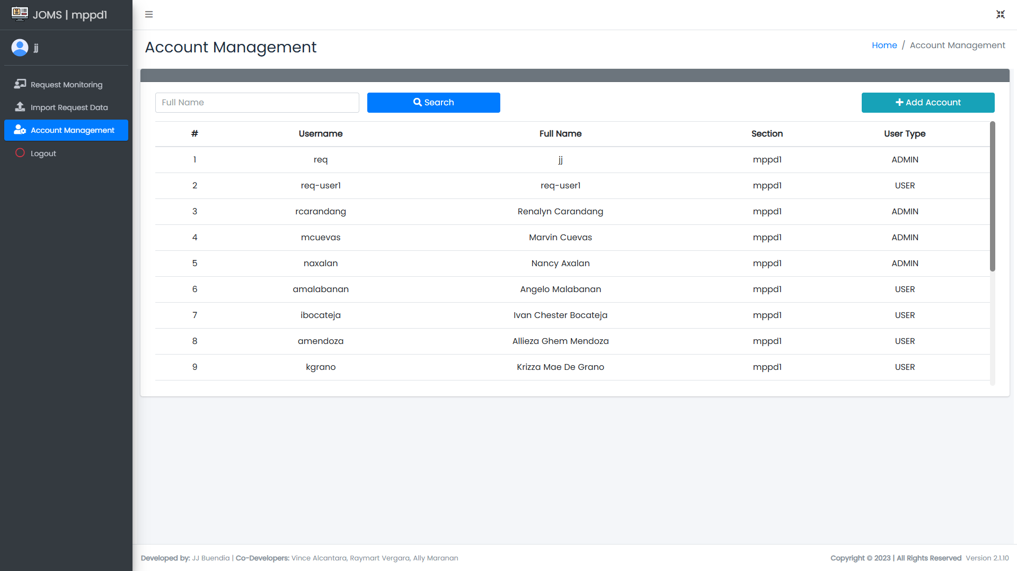

6.3

6.2

6.4

6.1

*Figure 9. MPPD1 Account Management Page*

1. **Log Out**

7.1 Click Logout. *(See Figure 10)*

7.2 Shows the message box. Click Logout button. Do not forget to logout when not using the system. *(See Figure 10)*

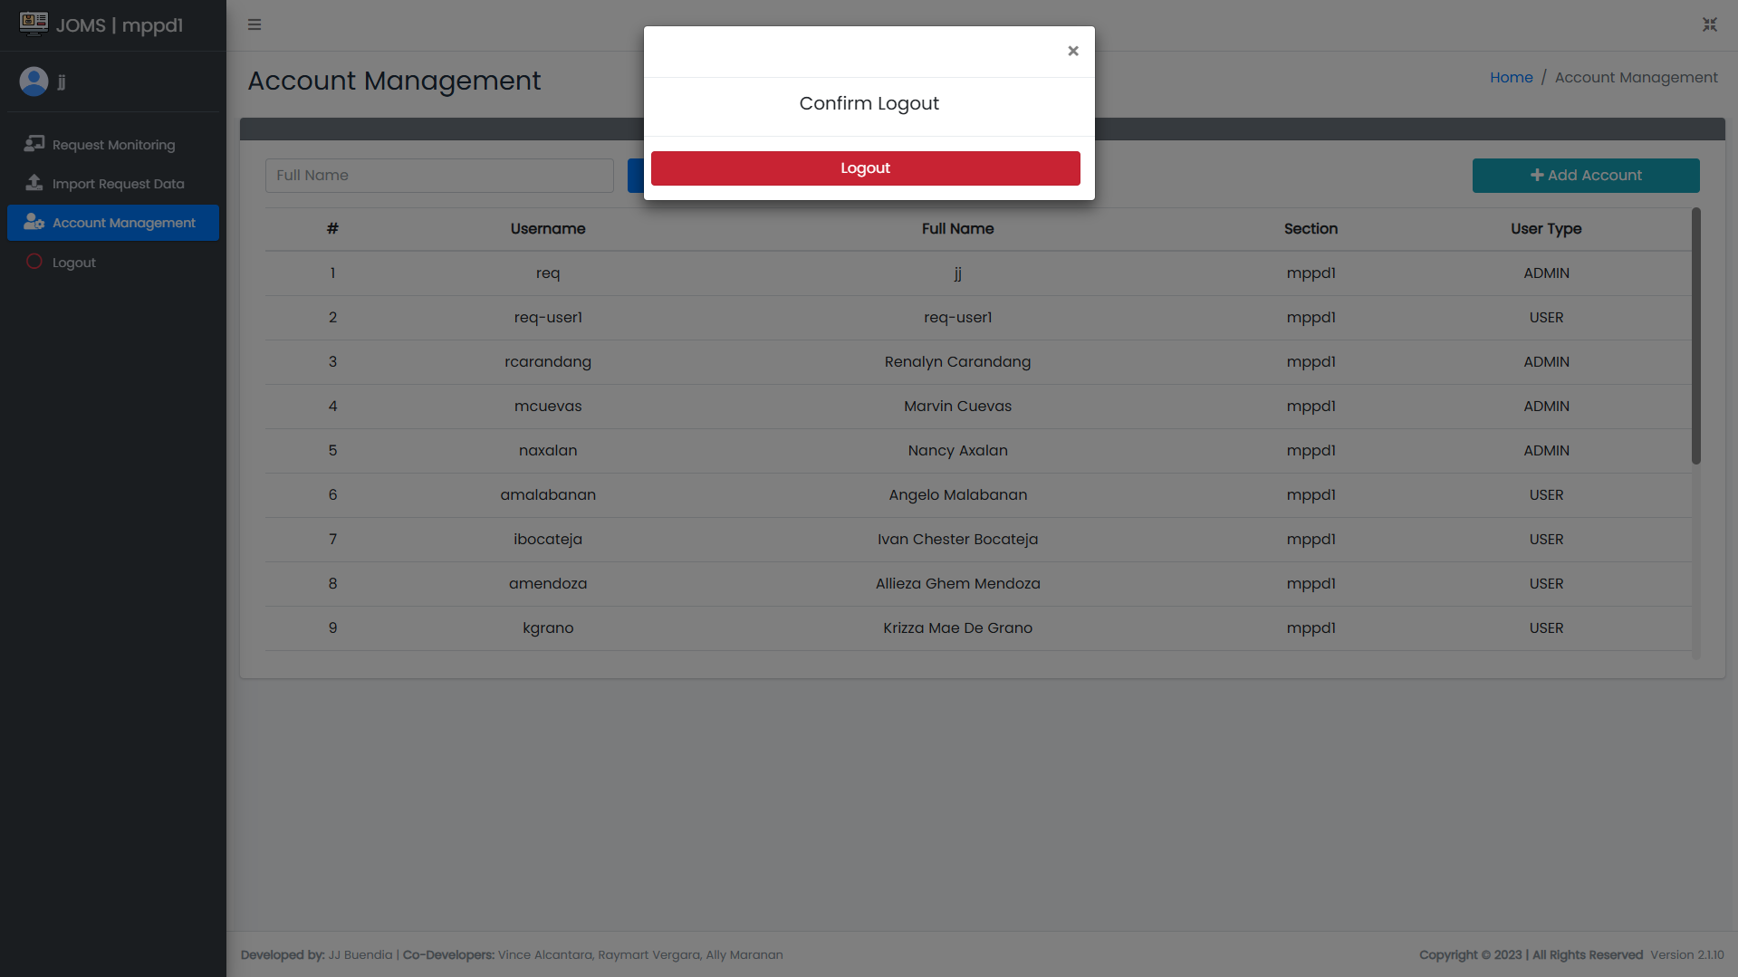

7.2

7.1

*Figure 10. Logout*

**III. AME3 / Purchasing Interface**

1. **Login**

1.1 Enter Username and Password. *(See Figure 11)*

1.2 Click Sign In Button to access Main Form. *(See Figure 11)*



1.1

1.2

*Figure 11. Login Page*

1. **Request Data**

2.1 Click Request Data button to access main form. *(See Figure 12)*

2.2 Viewer of list of request data uploaded by requestor. *(See Figure 12)*

2.3 Click Proceed of Export Request Data to download list of requested data. *(See Figure 12)*

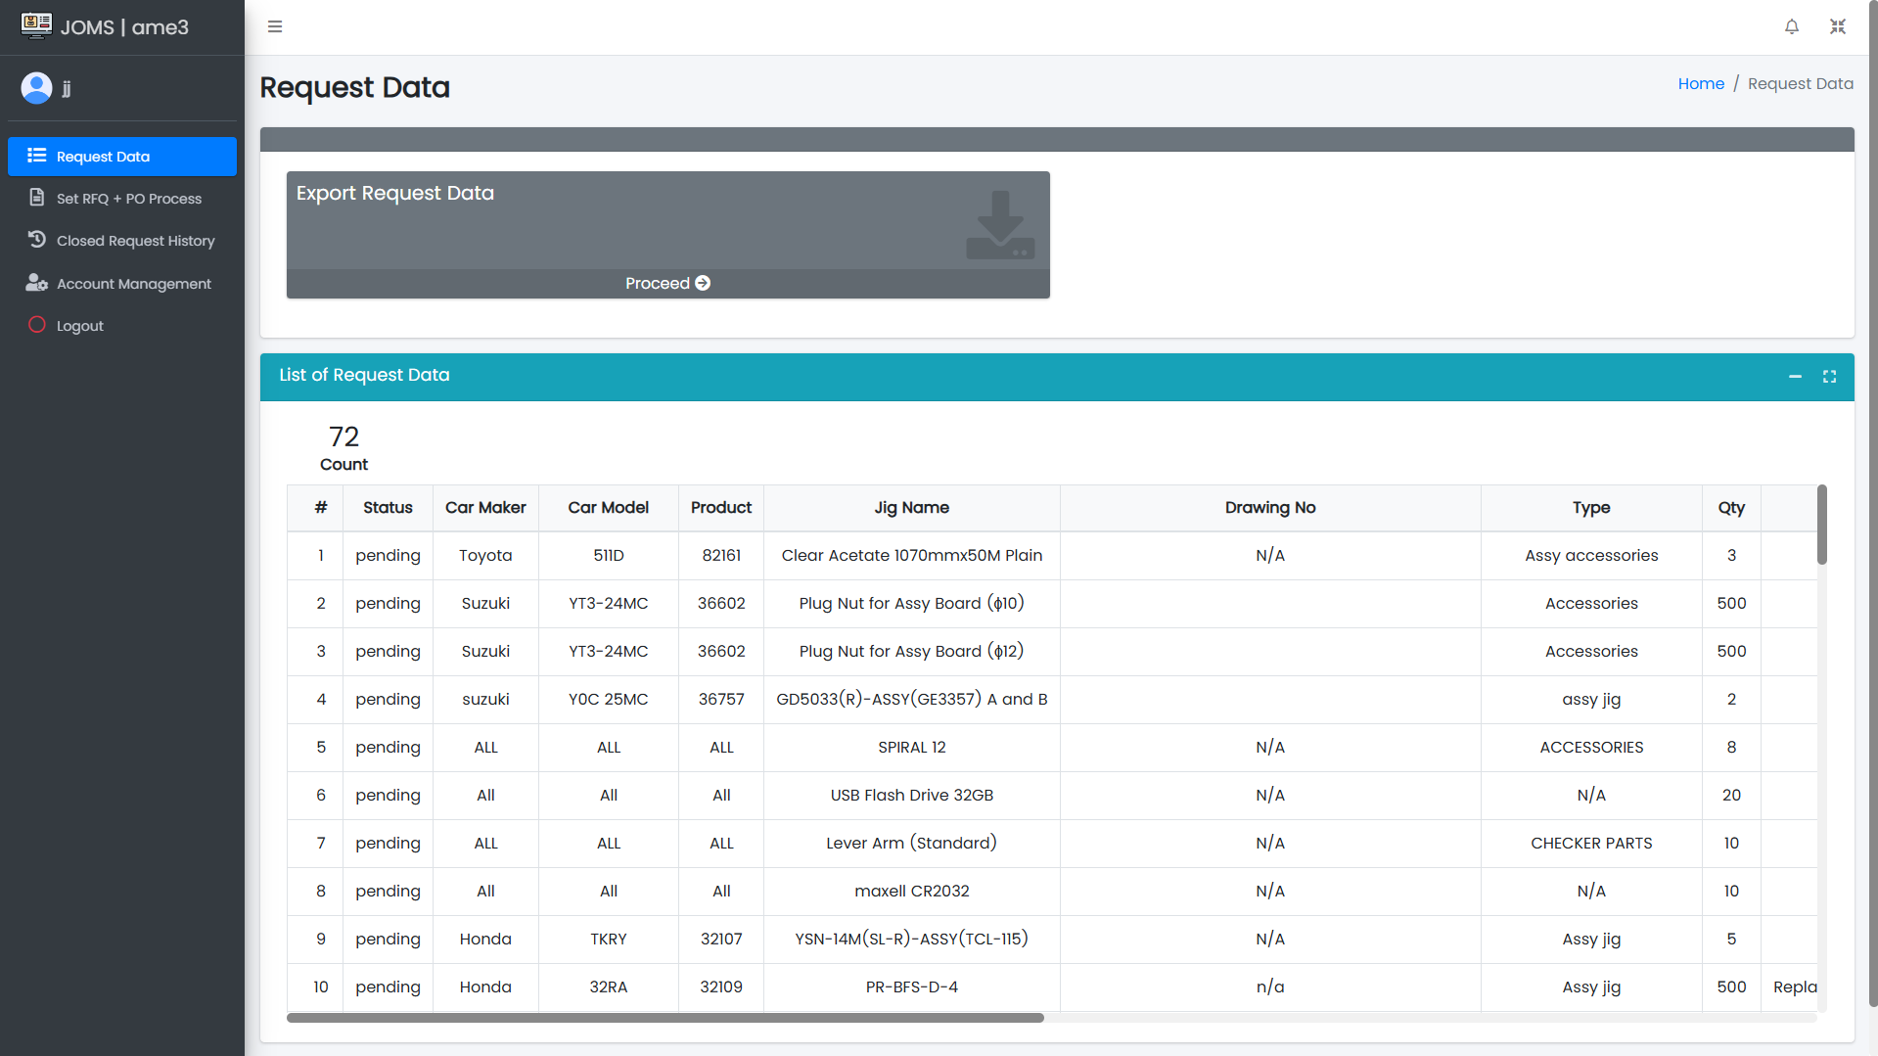

2.2

2.3

2.1

*Figure 12. AME3 Request Data Page*

2.4 After exporting, view the data then fill out the Initial RFQ missing data. *(See Figure 13)*

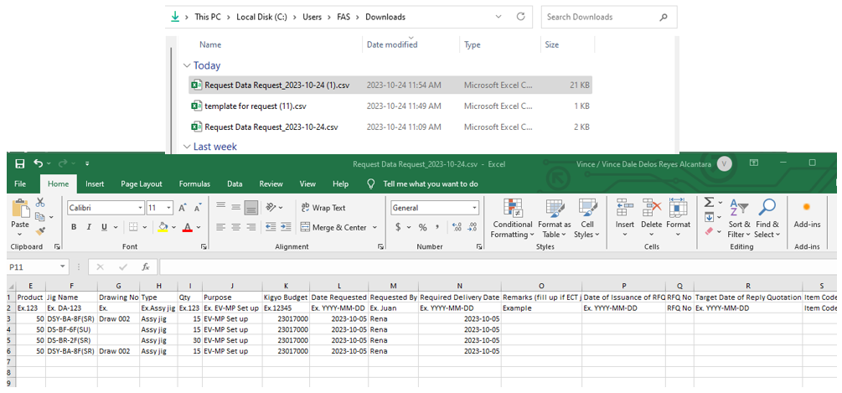

*Figure 13. Sample Request Data*

1. **Set RFQ and PO Process**

3.1 Click Set RFQ + PO Process button. *(See Figure 14)*

3.2 Click Proceed in Export Request Data + RFQ + PO. *(See Figure 14)*

3.3 Click Proceed in Import Request Data + RFQ + PO. *(See Figure 14)*

3.4 Filter table to RFQ Process or Initial RFQ or Complete RFQ or Cancelled. *(See Figure 14)*

3.5 Select item needed to be cancelled. *(See Figure 14)*

3.6 Click Cancel Request. *(See Figure 14)*

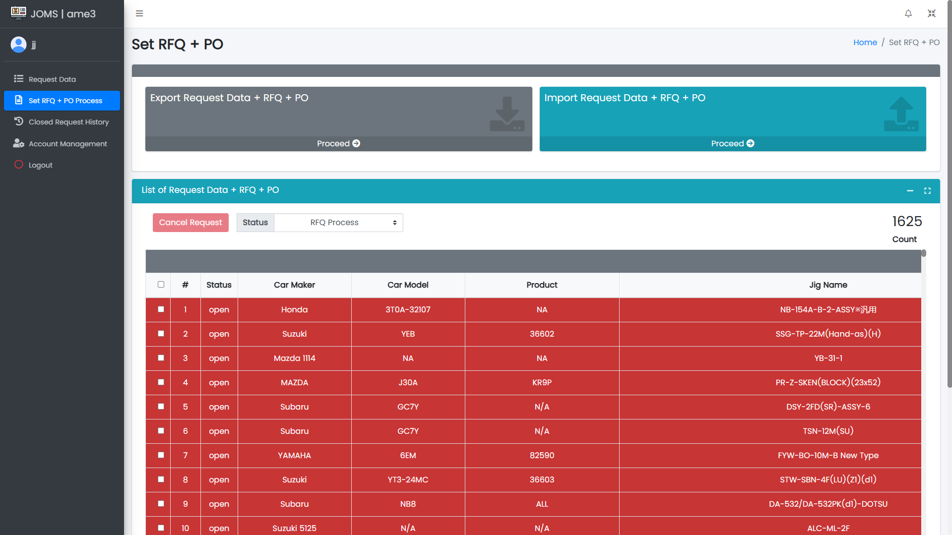

3.5

3.6

3.4

3.3

3.2

3.1

*Figure 14. AME3 Set RFQ + PO Process Page*

1. **Export Request Data + RFQ + PO**

4.1 Click Export Pending to export the request data. *(See Figure 15)*

4.2 Click Export Open Status to export with initial RFQ data. *(See Figure 15)*

4.3 Click Export Open Status to export with complete RFQ data. *(See Figure 15)*

4.4 Click Export Close Status to export with complete RFQ and PO data. *(See Figure 15)*

4.5 Click Export All Open Status to export all open request. *(See Figure 15)*

4.6 Click Export All Closed Status to export all closed request. *(See Figure 15)*

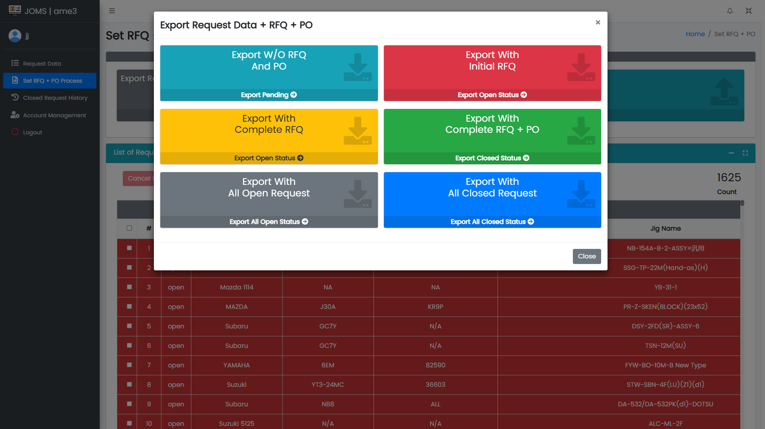

4.6

4.4

4.2

4.3

4.5

4.1

*Figure 15. Export Request Data + RFQ + PO*

1. **Import Request Data + RFQ + PO**

5.1 Click Import Initial RFQ in import req + initial RFQ. *(See Figure 16)*

5.2 Click Import RFQ in import req + initial RFQ. *(See Figure 16)*

5.3 Click Import PO in import req + complete RFQ + PO. *(See Figure 16)*

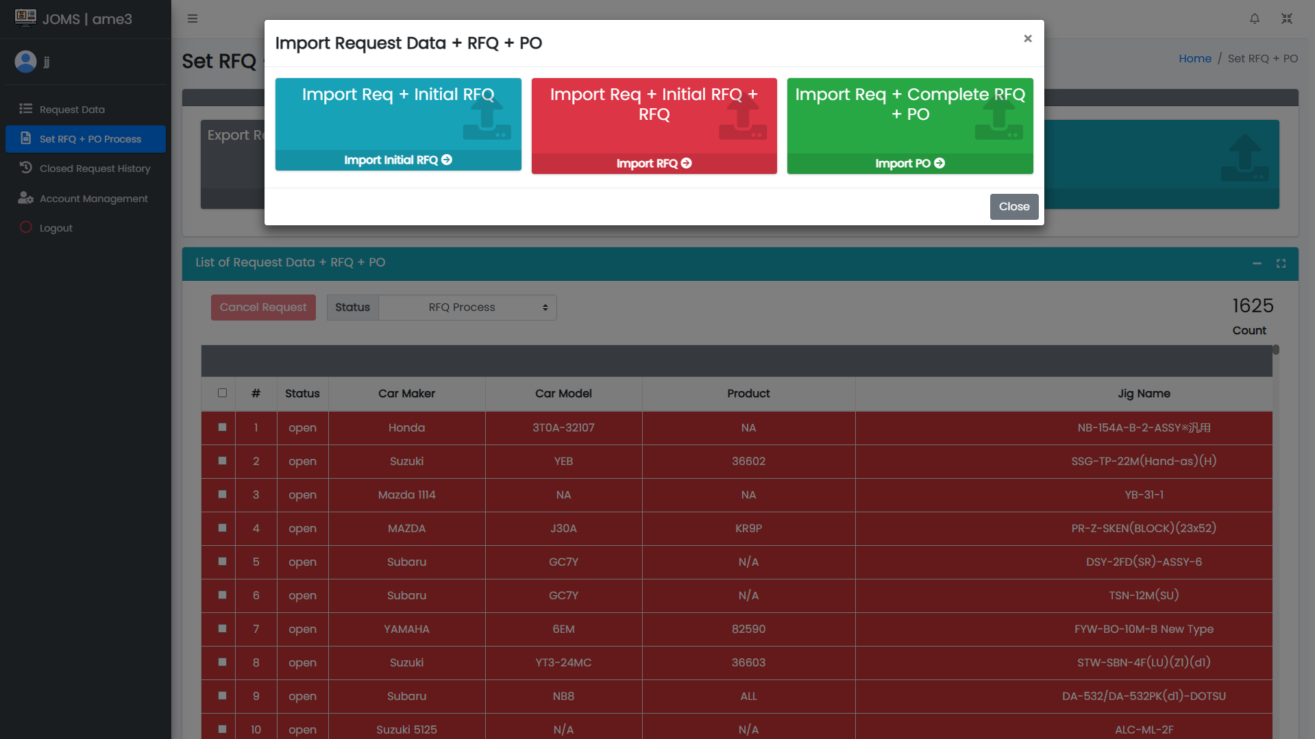

5.3

5.1

5.2

*Figure 16. Import Request Data + RFQ + PO*

5.4 After selecting which file will be imported – whether initial RFQ or RFQ or PO, choose the file that needs to be imported. *(See Figure 17)*

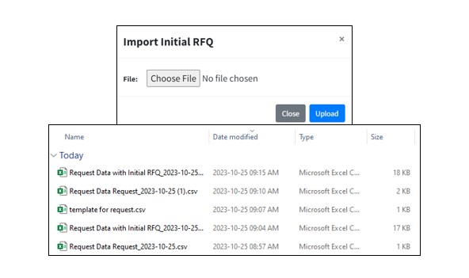

*Figure 17. Sample File Import*

1. **Cancellation Request**

6.1 To cancel, select the checkbox of item that needs to be cancelled. *(See Figure 18)*

6.2 Click the Cancel Request button to show the Cancellation for Selected Request. *(See Figure 18)*

6.3 Provide cancellation reason and cancellation date then, click the Confirm button. *(See Figure 18)*

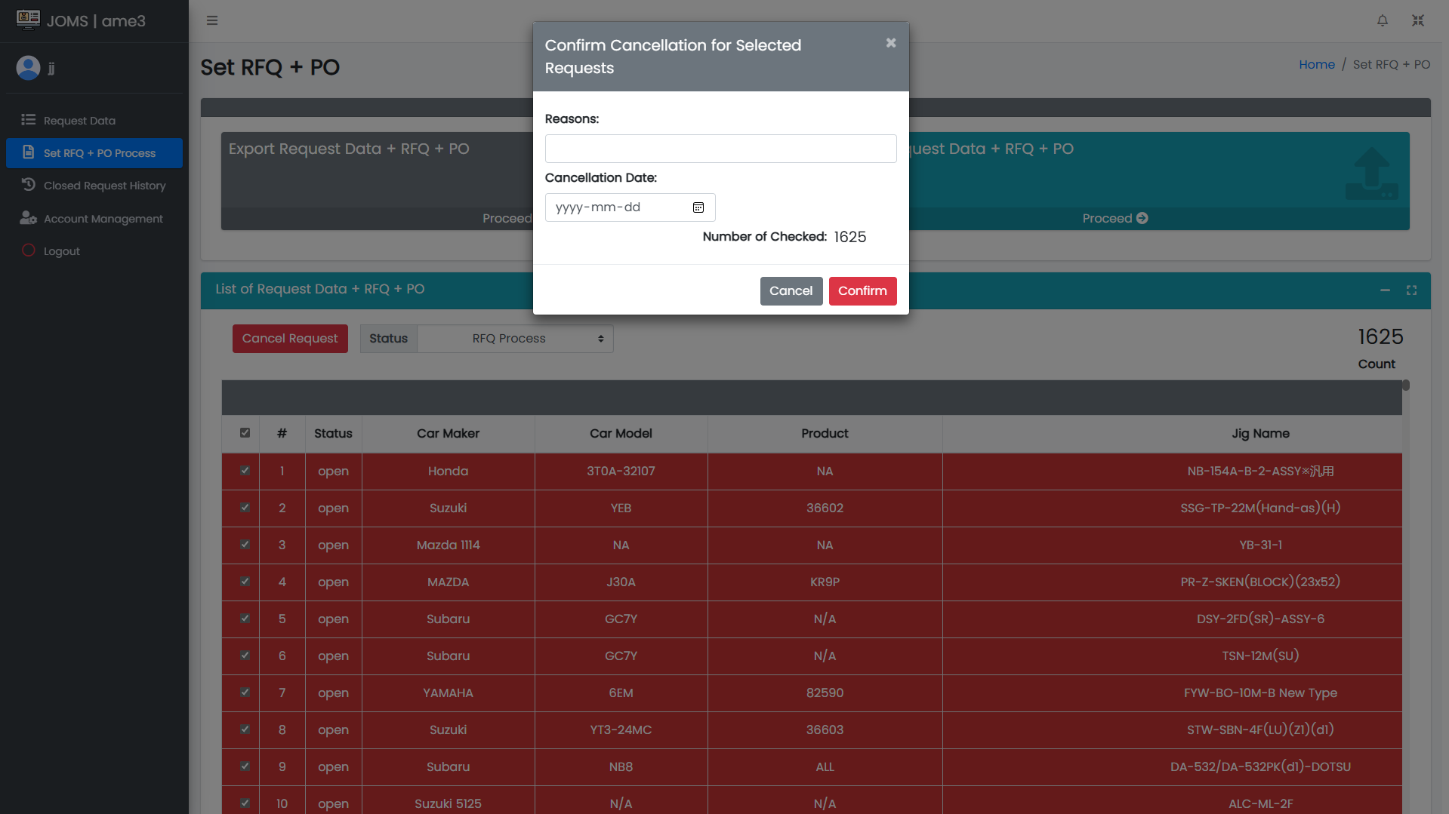

6.3

6.1

6.2

*Figure 18. AME3 Request Cancellation*

6.4 Click Section, the Status must be Cancelled. *(See Figure 19)*

6.5 Click Cancelled under Status column. *(See Figure 19)*

6.6 View the cancelled data. *(See Figure 19)*

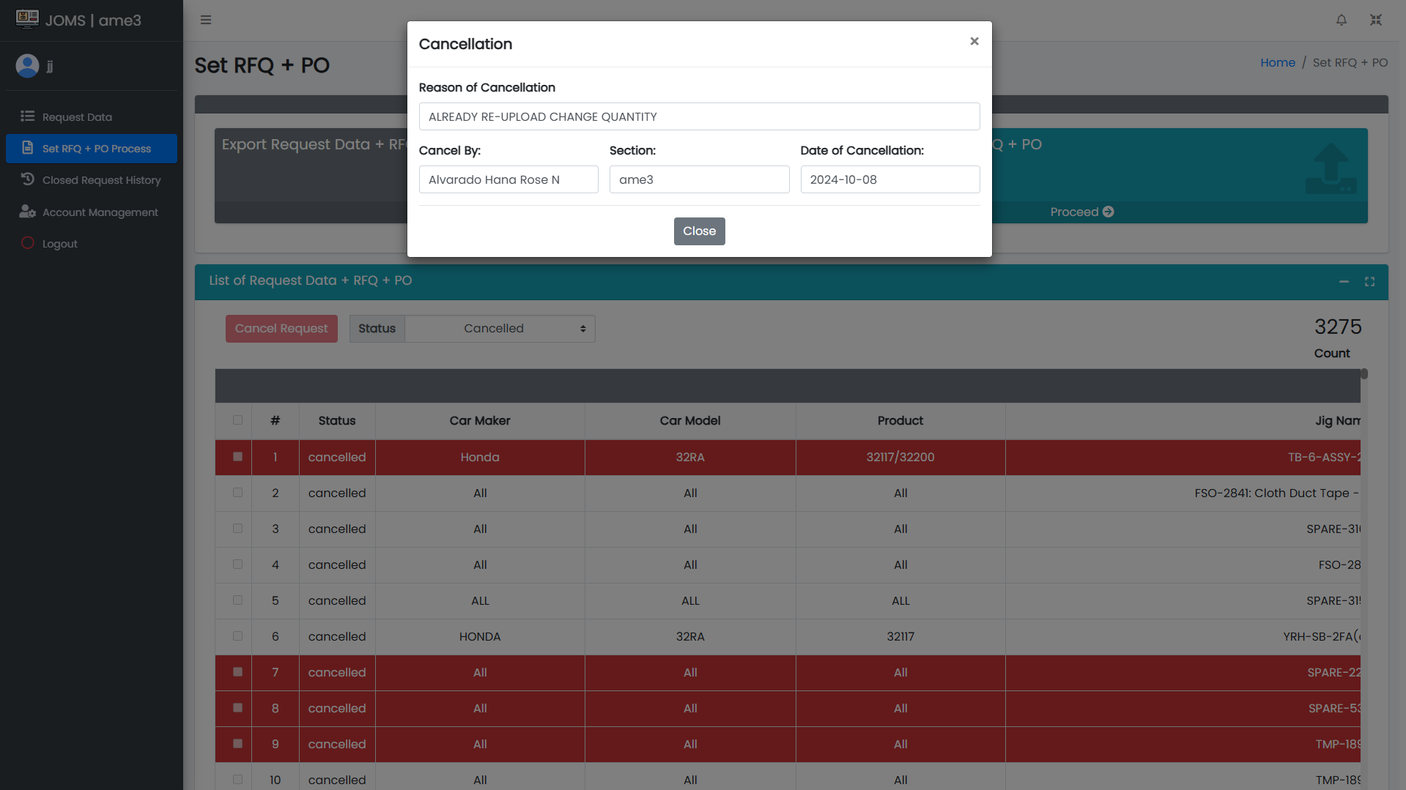

6.6

6.5

6.4

*Figure 19. AME3 Cancelled Request*

1. **Closed Request History**

7.1 Click Closed Request History. *(See Figure 20)*

7.2 Click the History Date From and History Date To (or RFQ No., Jig Name, Car Maker) in order to filter the table, then click Search. *(See Figure 20)*

7.3 Viewer of all closed data request by date. Also shows the total count of displayed data. *(See Figure 20)*

7.4 Click Export History to download the closed request data. *(See Figure 20)*

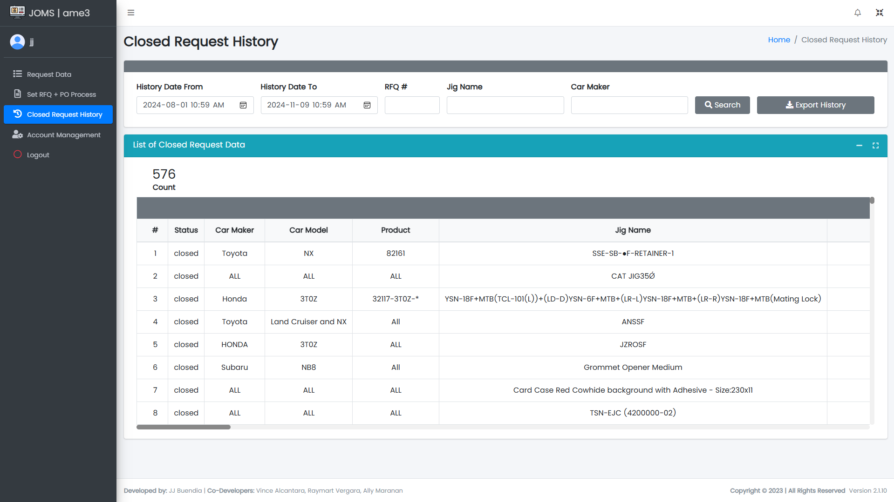

7.3

7.4

7.2

7.1

*Figure 20. AME3 Closed Request History Page*

1. **Account Management**

8.1 Click the Account Management. *(See Figure 21)*

8.2 Click Add Account to create an account. *(See Figure 21)*

8.3 View table of accounts. To update, click row of data to be updated and same goes when deleting an account. *(See Figure 21)*

8.4 Search account by full name. *(See Figure 21)*

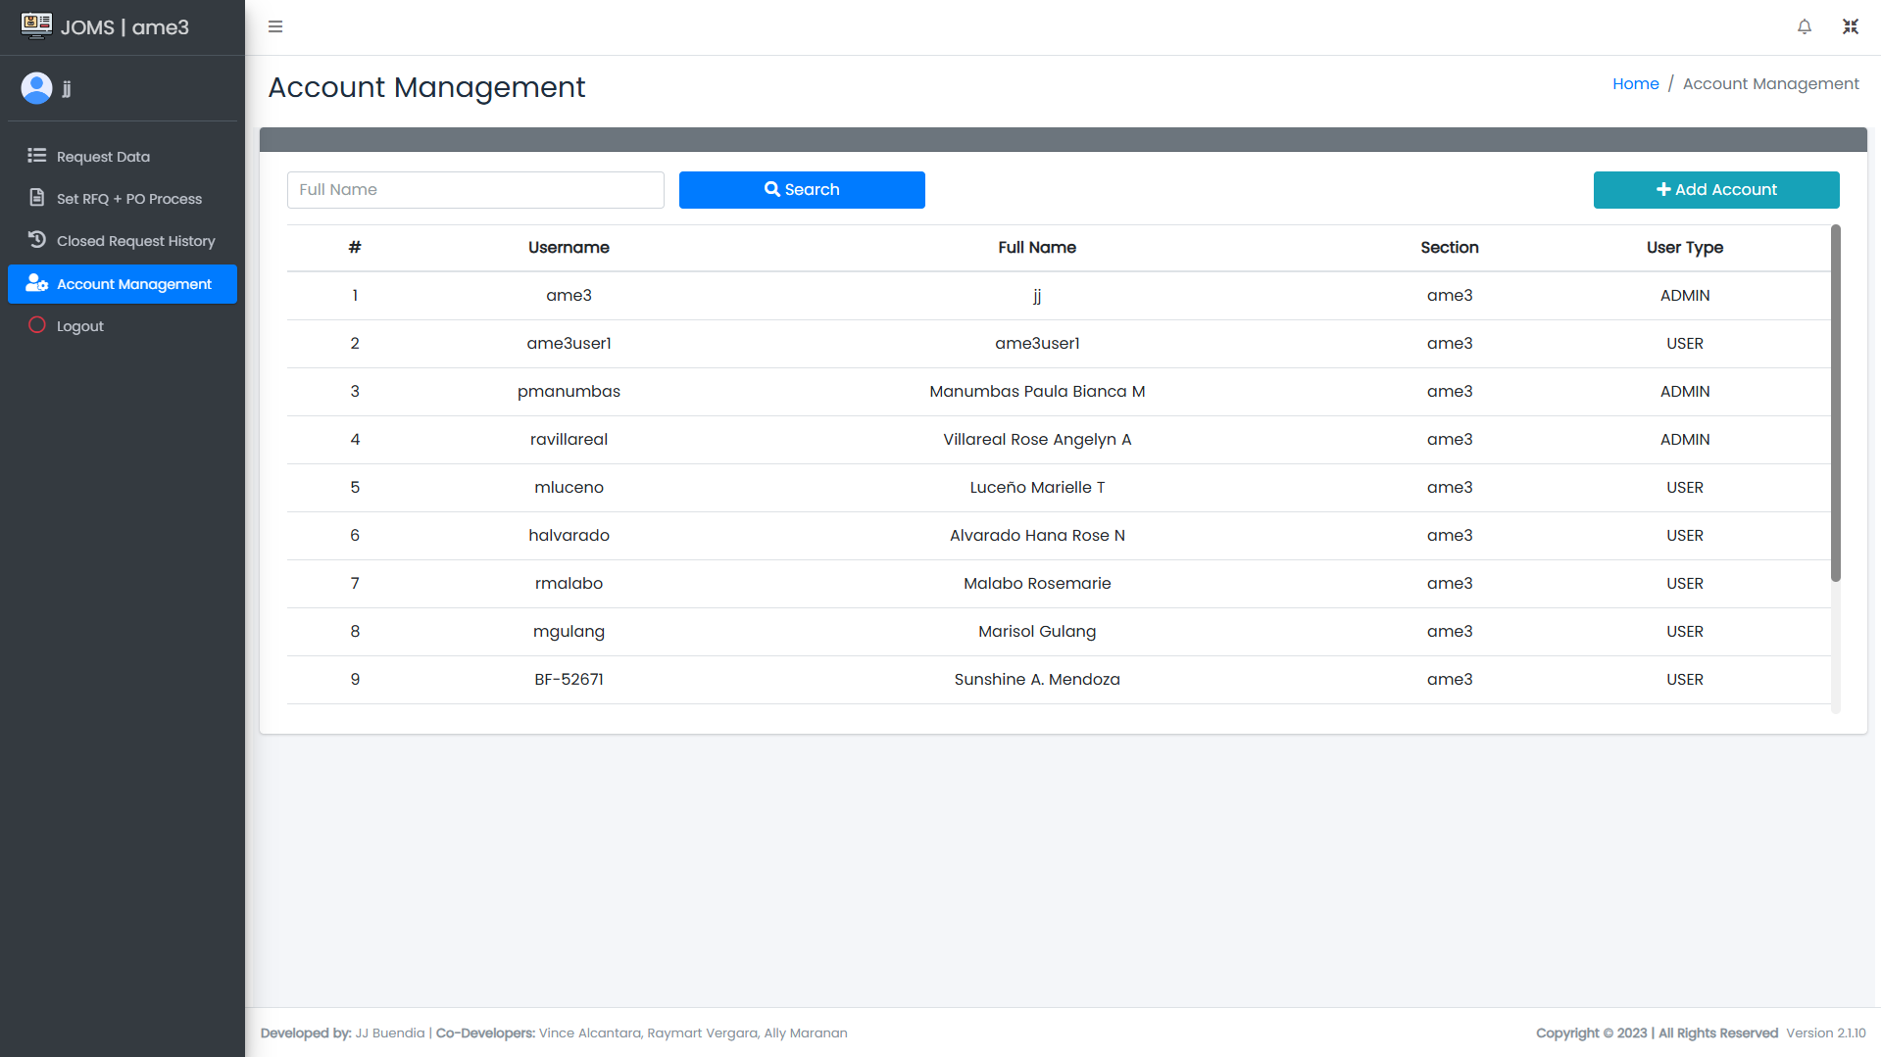

8.3

8.2

8.4

8.1

*Figure 21. AME3 Account Management Page*

1. **Logout**

9.1 Click Logout. *(See Figure 22)*

9.2 Shows the message box. Click Logout button. Do not forget to logout when not using the system. *(See Figure 22)*

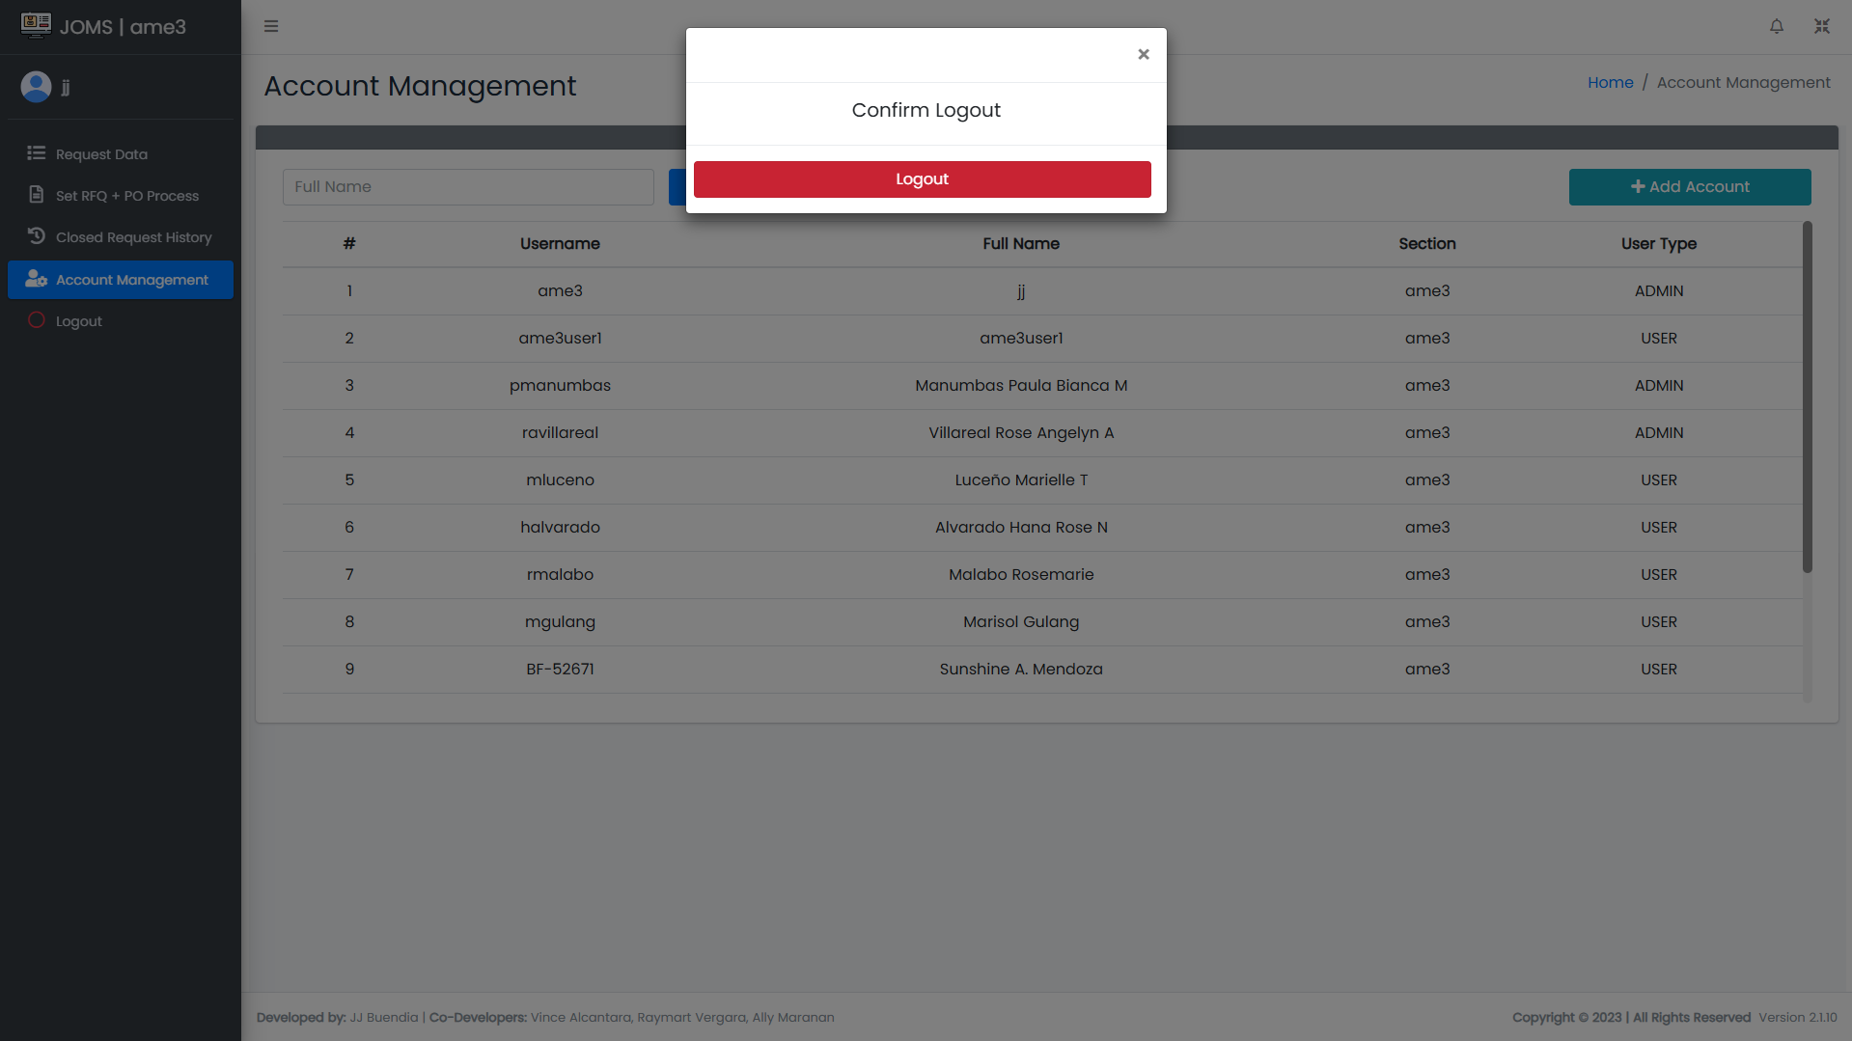

9.2

9.1

*Figure 22. AME3 Logout*

**IV. AME2 / Installation Interface**

1. **Login**

1.1 Enter Username and Password. *(See Figure 23)*

1.2 Click Sign In Button to access Main Form. *(See Figure 23)*



1.1

1.2

*Figure 23. Login Page*

1. **Request Without Installation Date**

2.1 Click Set Installation button to access main form. *(See Figure 24)*

2.2 Viewer has no installation date and line number yet. *(See Figure 24)*

2.3 View the count of request without installation date and line number. *(See Figure 24)*

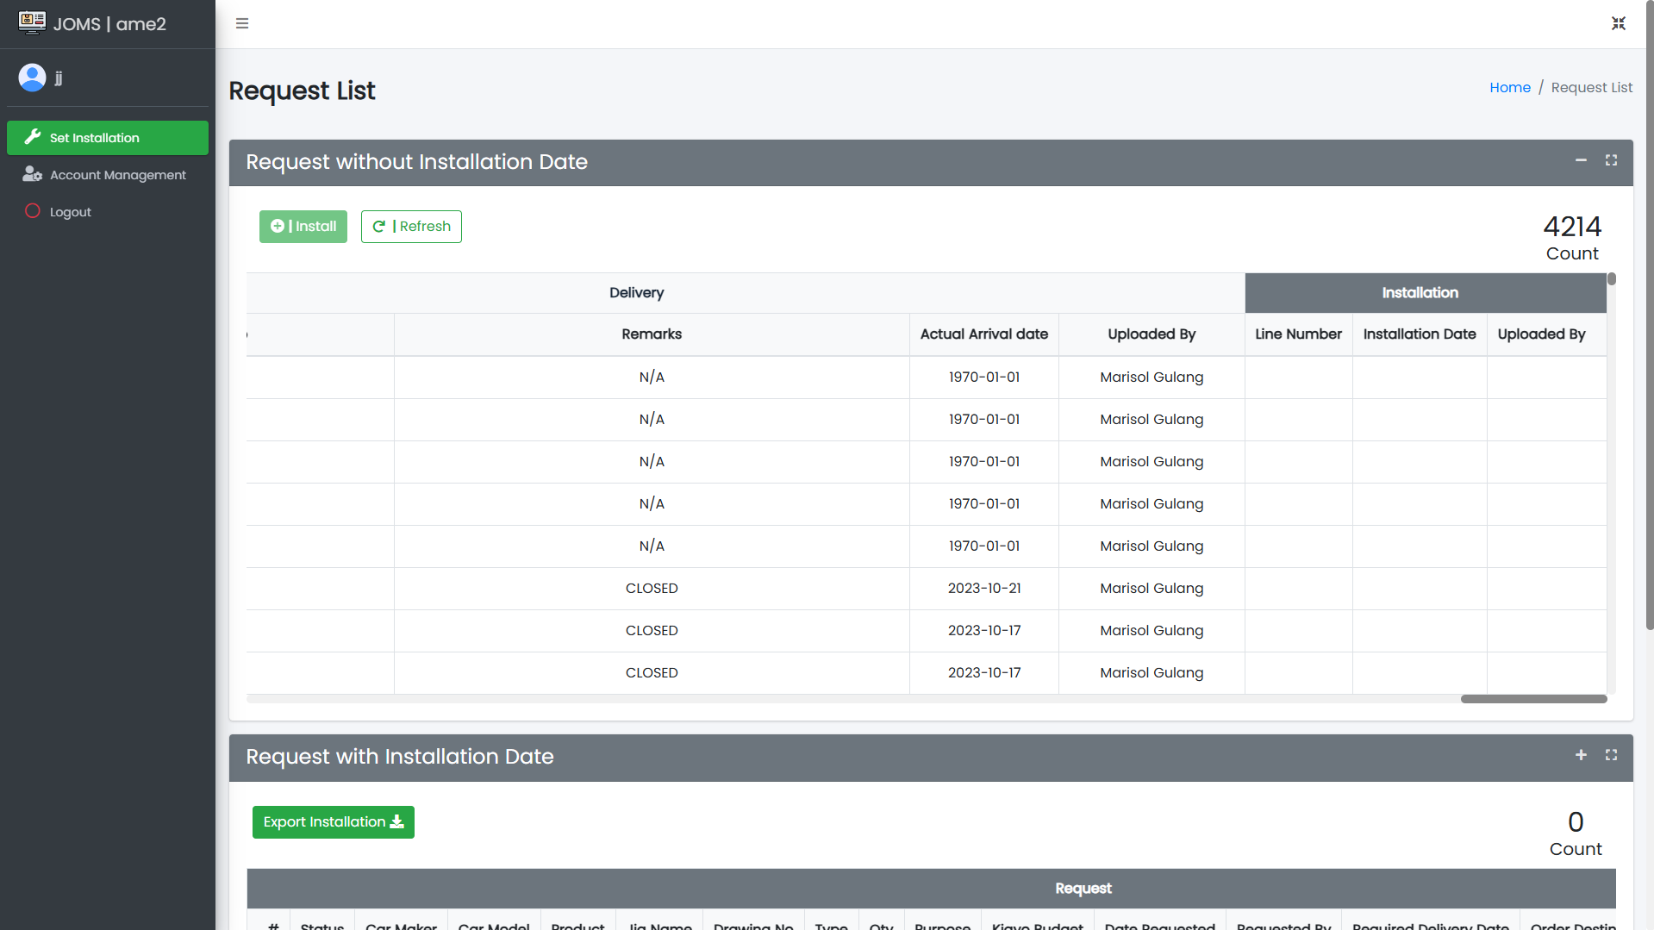

2.2

2.3

2.1

*Figure 24. AME2 Set Installation Page*

1. **Installation Process**

3.1 For date installation, select the checkbox of the item that needs to be installed. *(See Figure 25)*

3.2 Click the Install + to pop up the Installation Date for Selected Request. *(See Figure 25)*

3.3. Provide the line and select the installation date, then click the confirm button. *(See Figure 25)*

3.4 Click the refresh button to reload the content of requested date installation. *(See Figure 25)*

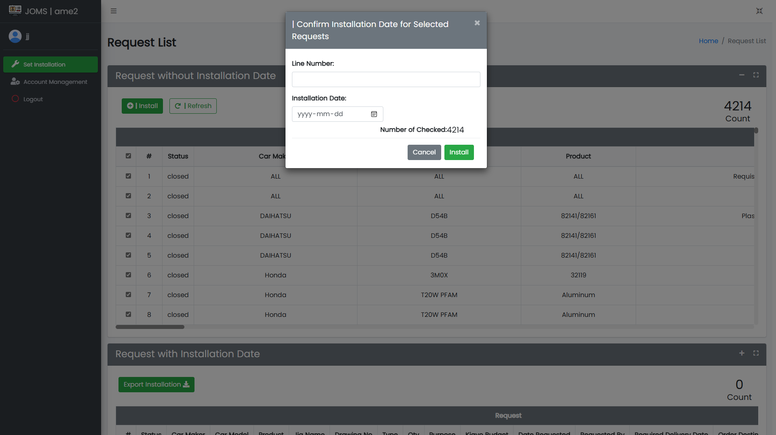

3.4

3.2

3.1

3.3

*Figure 25. Selected Request Installation Date Setting*

1. **Request with Installation Date**

4.1 Viewer has with installation date and line number. *(See Figure 26)*

4.2 View the count of requests with installation date and line number. *(See Figure 26)*

4.3 Export all installation data in csv format. *(See Figure 26)*

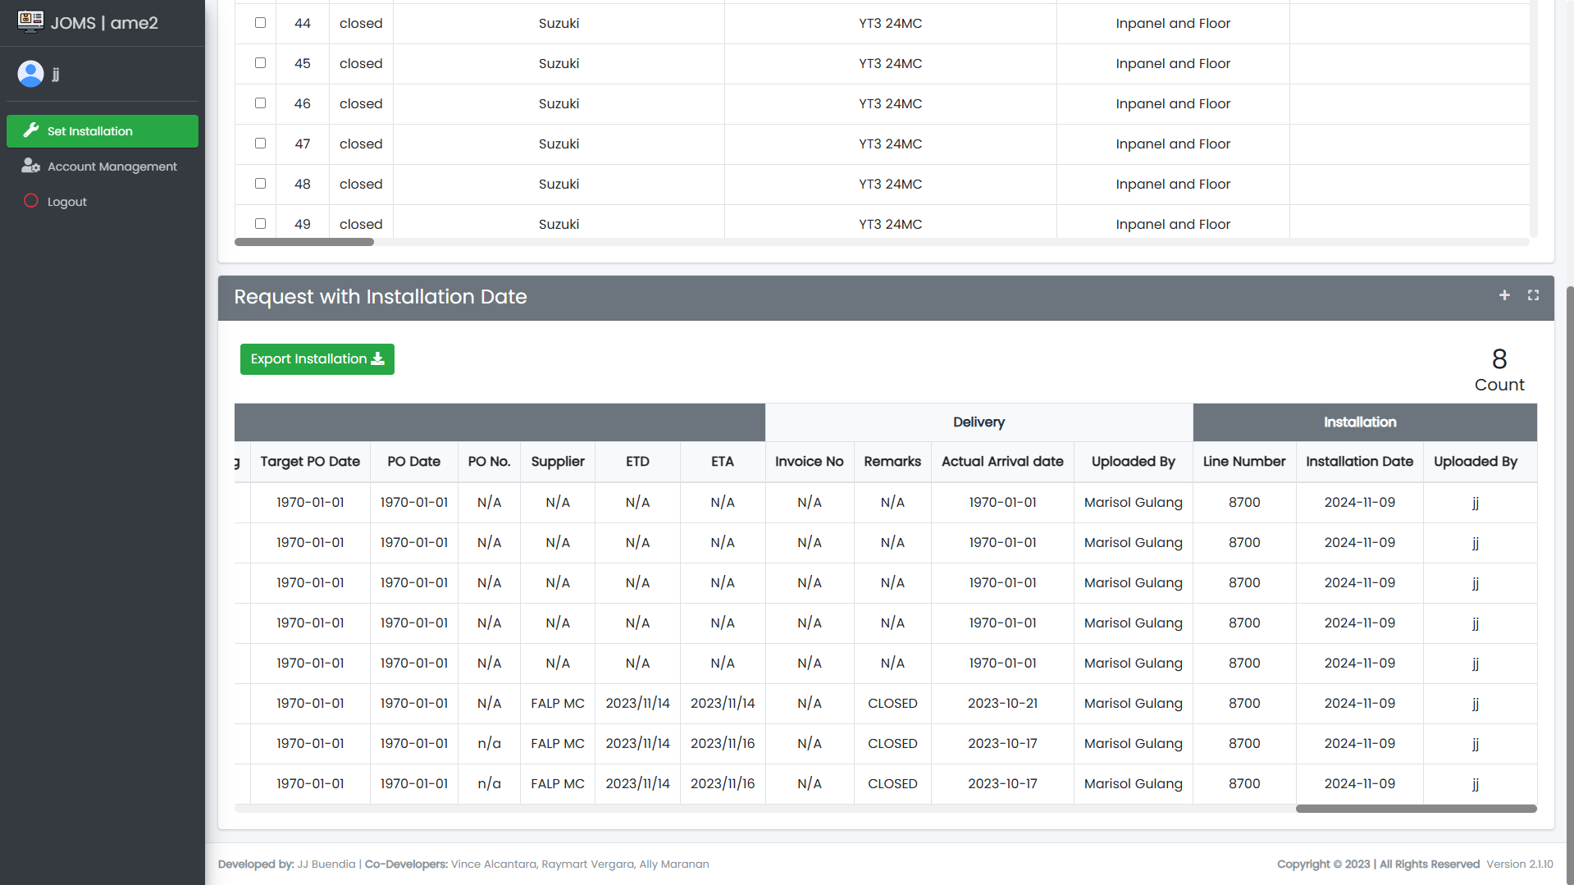

4.1

4.2

4.3

*Figure 26. Request with Installation Date*

1. **Account Management**

5.1 Click the Account Management. *(See Figure 27)*

5.2 Click Add Account to create an account. *(See Figure 27)*

5.3 View table of accounts. To update, click row of data to be updated and same goes when deleting an account. *(See Figure 27)*

5.4 Search account by full name. *(See Figure 27)*

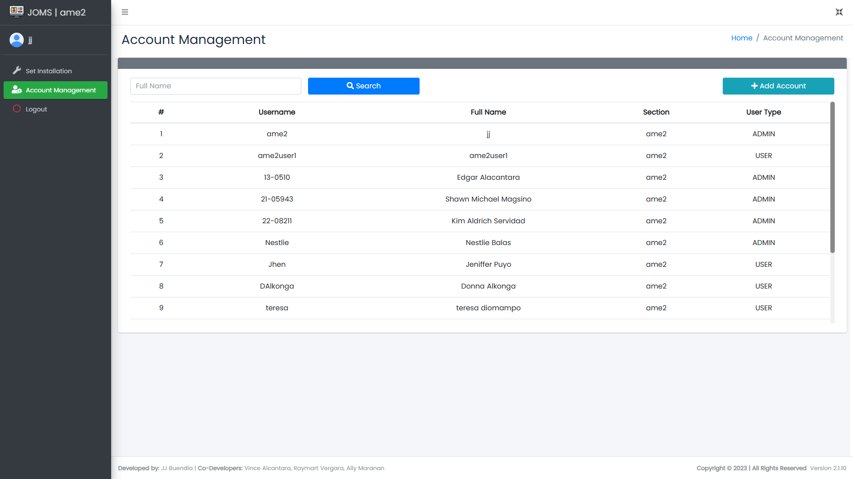

5.3

5.2

5.4

5.1

*Figure 27. AME2 Account Management*

1. **Logout**

6.1 Click Logout. *(See Figure 28)*

6.2 Shows the message box. Click Logout button. Do not forget to logout when not using the system. *(See Figure 28)*

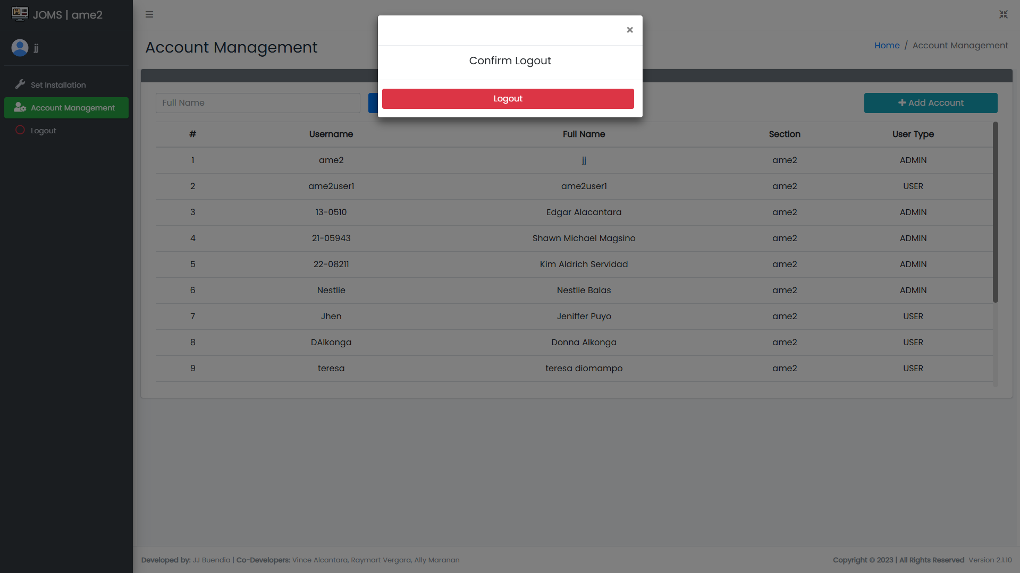

6.2

6.1

*Figure 28. Logout*

*-END-*